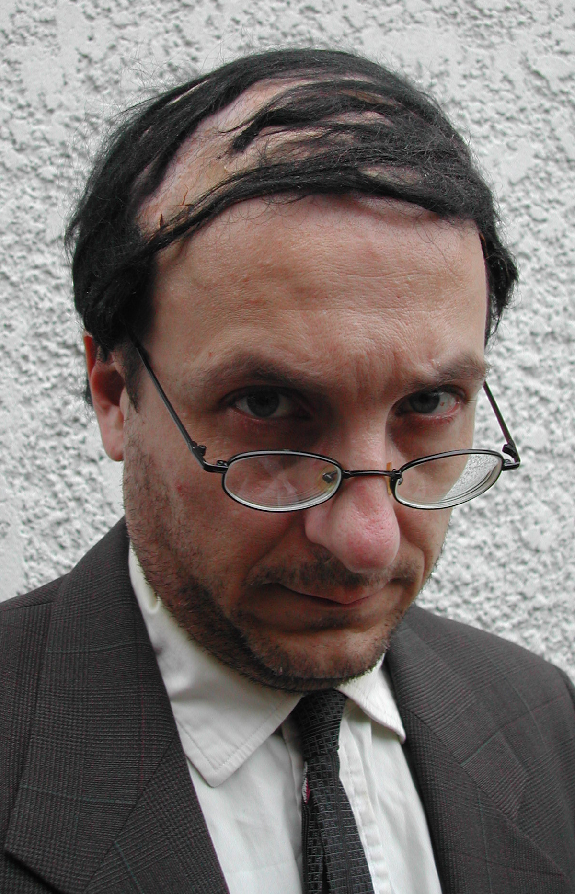
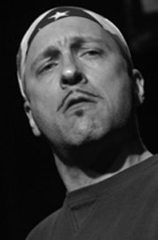
Robin Selfridge
SAG · AEA
5’7”, 155 lbs.
Brown Hair, Blue Eyes
(917) 757-1864
robin@RobinSelfridge.com

Stage
Manhattan Monologue Slam Original Characters NY Film Academy, NYC
Ivar Theatre, Hollywood, CA
Schooled One-Man-Show UCB Theatre, NYC
Fortinbras Captain National Shakespeare Co., NYC
Moon Over Miami various roles Yale Repertory Theatre, CT
Red Ridin’ in the Hood The Storyteller Henry Street Settlement, NYC
Sgt. Rock has all his teeth Sgt. Rock Nada Theatre, NYC
Cloud 9 Betty/Gerry Performance Studio, CT

Comedy & Improv
Normalville long-form improv The Peoples Improv Theatre, NYC
One Take short-form improv Mohegan Sun Cabaret, CT
Serious Pratfalls Featured Toyota Comedy Festival, NYC
TheatreSports NY short-form John Houseman Theatre, NYC
For Play (MAC Award winner) long-form The Producers Club, NYC

Internet
IMPROVe producer/performer Pseudo Programs, INC., NYC
The Carton performer/writer Pseudo Programs, INC., NYC

TV/Film
Café DéClassé Jean Pierre/Uncle Sid WTNH Channel 8, CT
Domestic Violence dramatizations WTNH Channel 8, CT
20 Questions Featured Generic Films, CT
Up All Night Featured USA Network, NYC

Training
BFA, University of Wisconsin-Eau Claire
MA, Brooklyn College
Long-form Improv: Katha Feffer, NYC; Upright Citizen’s Brigade, NYC

Skills
Comic Characters, Sings Tenor, Plays Guitar
Visual Artist (painting, drawing, printmaking, ceramics)
Carpentry and Construction, Magic, Drives stick (bus)

